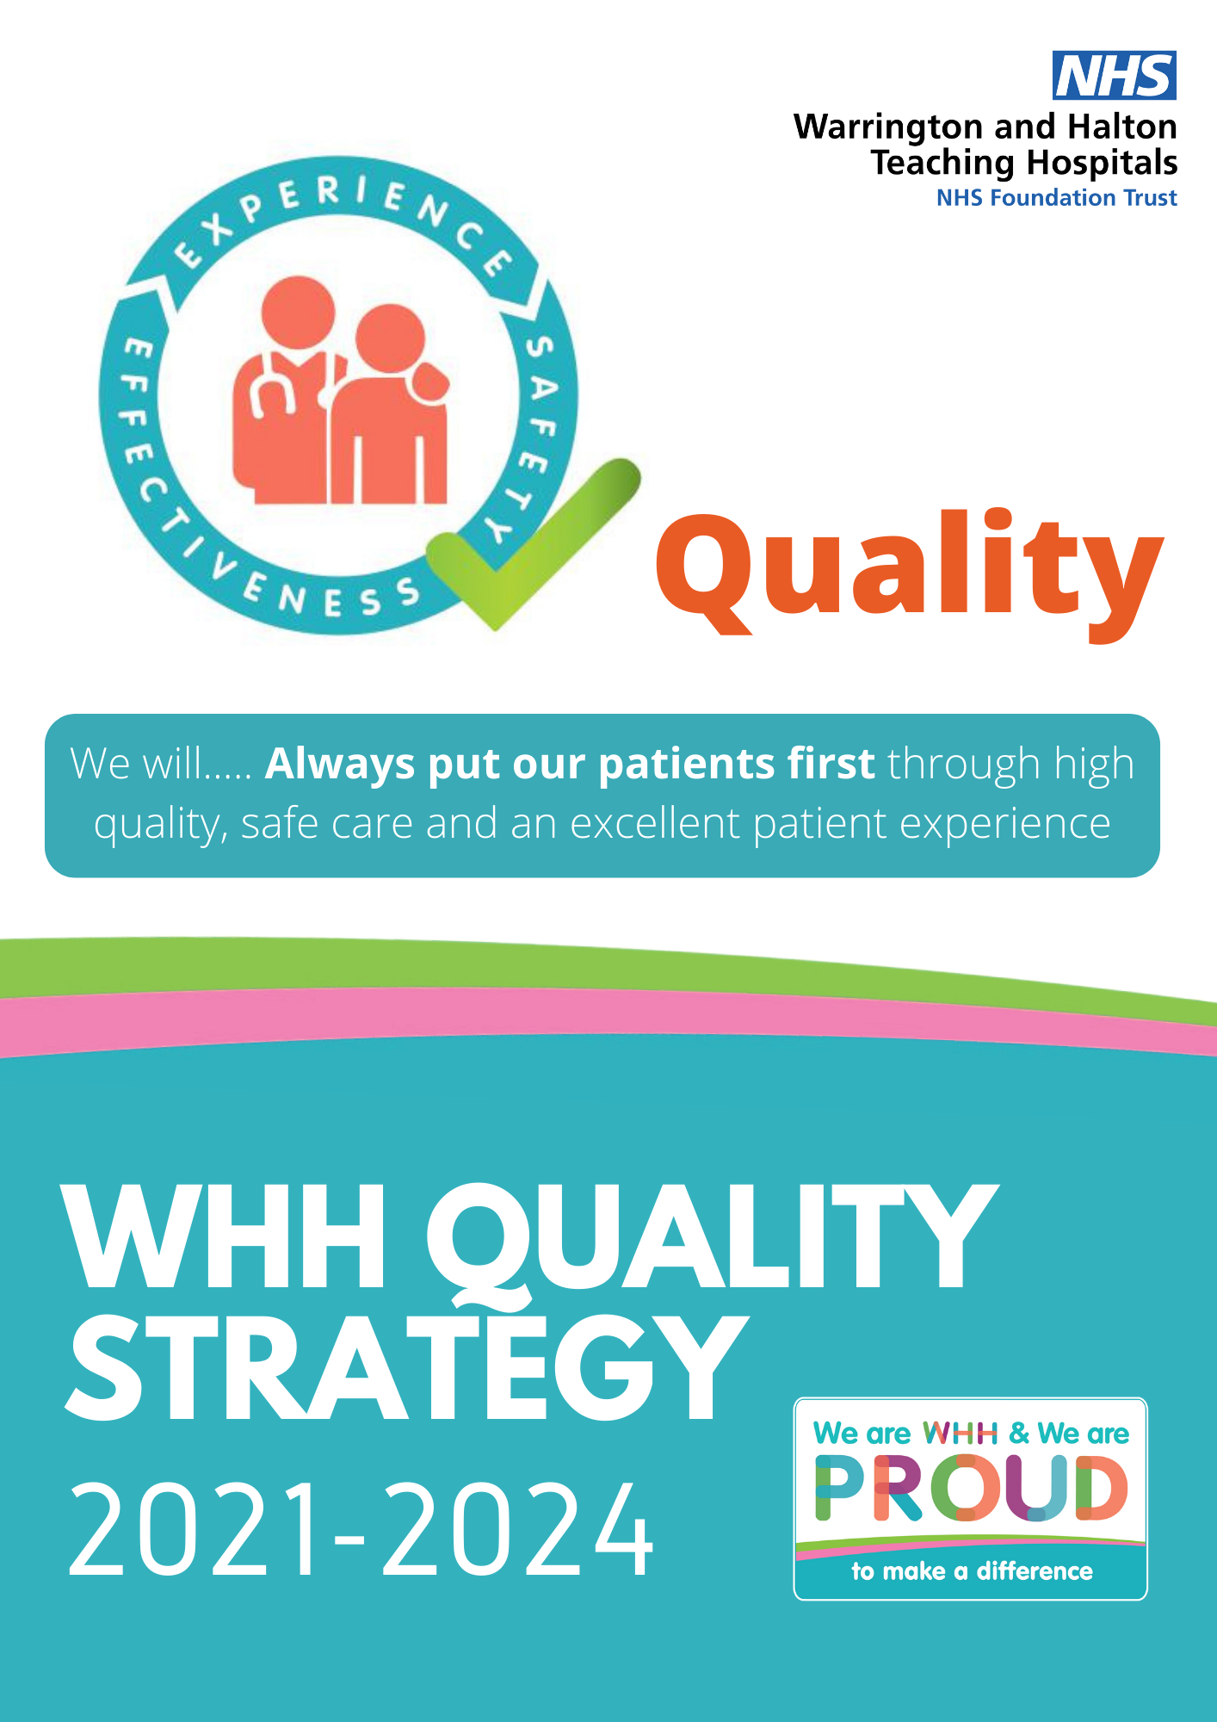

|  |
| --- |
| Foreword |

|  |
| --- |
| Who We Are |

|  |  |
| --- | --- |
| **Simon Constable**  **Chief Executive**   | Warrington and Halton Teaching Hospitals NHS Foundation Trust is dedicated to the provision of high-quality care and clinical excellence. Recognising that our patients and staff deserve nothing less than OUTSTANDING, we have embarked on an organisation-wide journey called ‘Moving to Outstanding’.  We are proud to present our Quality Strategy 2021 - 2024 which is built upon the foundations of our Quality, People and Sustainability Framework (QPS).  Over the past three years we have achieved so much and have evidenced the delivery of high-quality care despite the challenges of the Covid-19 pandemic. The new three year Strategy will focus upon our continued commitment to deliver the highest quality of care to our patients and optimise health outcomes. This will be supported by our plans to become a recognised ‘outstanding’ organisation.  Having focussed on delivering continuous quality improvements over the past three years we are now seeking to deliver a more comprehensive strategic approach that embeds quality within the very fabric of everything we do, ensuring high quality safe care. This will be further enhanced by the exciting introduction of our newly established Halton Clinical Research Unit. We will continue to ensure that care is delivered in an open, transparent and compassionate way. We will continue to drive the Trust’s Quality Strategy priorities as noted below. These will be refocused and agreed each year.  **Priority 1** We will reduce avoidable harm and patient deterioration with focus on COVID-19 recovery by managing and reducing clinical and operational risks.  **Priority 2** We will improve patient outcomes, based on evidence and deliver care in the right place, first time, and every time.  **Priority 3** We will focus on the patient and their experience, adopting ‘no decision about me without me’ as a way of life and we will get the basics right so our patients will be warm, clean, and well cared for.  The areas we have chosen to focus on as priority areas are:   * Gram Negative Bloodstream Infections (GNBI). * Improvement in the communication process for DNACPR. * COVID-19 Recovery. * Embedding the Medical Examiner role, including community implementation. * Ensure effective decisions about health care are based on the best available, current, valid and reliable evidence. * Clinical Business Unit (CBU) governance to be strengthened further. * Implementation of the End of Life Serious Illness Programme. * Development and implementation of the Trust Learning Disability and Mental Health Strategies. * Improve the standard and choice of food available to patients.   The priorities have been chosen based upon national and local drivers and our internal governance intelligence. Emphasis remains upon working across organisational boundaries in partnership with others and across the Integrated Care System (ICS), to ensure that we provide efficient and safe patient pathways to optimise health outcomes and improve the experience for our patients. |

|  |
| --- |
| Welcome to Our Quality Strategy 2021- 2024 |

|  |  |
| --- | --- |
| In 2018, we launched our first Quality Strategy which outlined our commitment to prioritise quality above all else. Our new three-year Strategy will build upon this commitment to support all staff in our aspiration to become an ‘outstanding’ organisation.  This Quality Strategy details our ambitious plans to deliver sustained, significant and continuous improvement to the quality and safety of the care that we provide for our patients. Quality Improvement (QI) will continue to be an integral part of everyone’s daily work with learning shared effectively across the organisation.  We will continue to work towards a culture which encourages innovation, experimentation and change. This will be supported by the additional investment made in 2020 for Quality Improvement and the newly opened Halton Clinical Research Unit.  Covid-19 has brought a number of challenges over the past year, but staff have evidenced exemplary leadership capability, creativity and innovative ways of working to deliver high quality, safe care in the most challenging of times. The learning gained through this period will influence the way in which we deliver our services to ensure, safety, efficiency and a positive patient experience across all services.  It is well recognised that all Trusts will be met with challenges as part of Covid-19 recovery and we are committed to ensure that all staff are supported and equipped to meet these challenges whilst driving the standard of care delivered to all of our patients. We remain committed to our aspiration of becoming an ‘outstanding’ Trust that delivers the highest standards of care to all patients, all the time, building upon our 2019 Care Quality Commission (CQC) inspection where the Trust was awarded a ‘Good’ rating.  We look forward to working with staff to support the implementation of this Strategy which will be monitored by our Board of Directors, Quality Assurance Committee and by our public and partners through the reporting of measurable success detailed within our Trust Annual Quality Account.  Thank you all for your continued hard work. | **Kimberley Salmon-Jamieson**  **Chief Nurse and Deputy Chief Executive**    **Alex Crowe**  **Executive**  **Medical**  **Director** |

|  |
| --- |
| Introduction |

**Who We Are:**

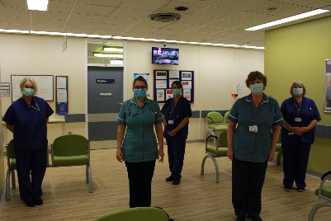Warrington and Halton Hospitals NHS FT comprises of two acute (secondary) care hospitals across two sites in the Boroughs of Warrington and Halton, making us part of the mid-Mersey health economy. Warrington Hospital is the home of all our emergency and complex surgical care and maternity services while Halton General Hospital and the Captain Sir Tom Moore facility in Runcorn is a centre of excellence for planned routine surgery.

Although each hospital focuses on aspects of care, we provide outpatient clinics for all our specialties and diagnostic (scanning) services at both Warrington and Halton sites so patients can access their appointments closer to home wherever possible. We also provide some outpatient services in the local community.

In delivering the NHS Long term plan (2019) we are part of the Cheshire and Merseyside Health and Care Partnership, the second largest Integrated Care System in the country; integral in both One Halton and Warrington Together ‘place based’ health and social care systems. We serve a population of 330K across both boroughs and employ over 4,200 staff comprising 52 nationalities.

We became a Foundation Trust in 2008 and have over 15K ‘members’ across the boroughs of Warrington, Halton and surrounding areas and occasionally beyond. These members are represented by our Council of Governors comprising public (elected), staff and partner governors who are committed to representing the views of service users and public within their constituencies.

**What Guides Us – Our WHH Values**

Our work is underpinned by our values statement which sets out five value sets: These values and associated behaviours will support the creation of a compassionate, inclusive and high-quality care culture that enables excellence in quality and safety to flourish.

**Embedding Our WHH Values into Our Quality Strategy**

This Quality Strategy is an enabling Strategy that supports the delivery of our overall Strategy. This Quality Strategy sets out our plans and commitment for the next three years to put our patients and our communities at the heart of what we do. Work will continue building strong partnerships **Working Together,** to have an unrelenting focus on **Embracing Change** and improving the quality and safety of our services, to deliver our ambition to be as productive, **Inclusive** and efficient as we can be. The experiences of our colleagues and our patients will continue to be the most important measure of our progress. It is the delivery of this Strategy, together with the supporting strategies of patient experience, people and our sustainability plans that will ensure that we act with kindness as role models to deliver **Excellence** in quality, safe and sustainable health and care services for the local population of Warrington and Halton and beyond.

|  |
| --- |
| What Are We Trying to Accomplish? |

Quality is ournumber one priority: ‘We are committed to developing and enhancing our patients’ safety through a learning culture where quality and safety is everyone’s top priority’, it is the first strategic objective of the Trust under the Quality domain.

This Quality Strategy is a guide for all colleagues, patients and governors to ensure that we deliver excellent care, every time, to every patient. Our aim is to create a culture of continuous improvement and learning which are both patient-centered and safety- focused.

A national Patient Safety Strategy ([NHS England 2019)](https://www.england.nhs.uk/patient-safety/the-nhs-patient-safety-strategy/)  focuses on three aims. Our Strategy for quality is based on the same three aims. These are:

1. To be world leading at drawing insight from multiple sources of information.
2. To give staff at all levels the skills and support they need to improve safety and quality so that they can be the infrastructure for improvement working with patients and partner organisations.
3. To decrease harm in key areas by 50% by 2023/24 and beyond through specific initiatives targeted at safety and improvement.

To do this, we must create the conditions where we:

* Listen to and include the views of our staff and key stakeholders.
* Have access to and actively use the comprehensive evidence base from the medical and nursing literature to ensure that we use the best interventions to improve the quality of care that we provide.
* Provide clinical staff with the data that they need to make the best decisions about clinical care.
* Fully embed the Trust Values in everything that we do in order to ensure the working environment is conducive to the enablement of continual improvement and innovation.
* Actively engage with and enable staff to lead and deliver measurable change for improvement.
* Focus on human factors and how we deliver care as teams.
* Are open and honest with people when things go wrong and make sure that we learn from errors.

|  |
| --- |
| **We must ensure that we create the culture of learning, openness, transparency and candour consistent with the recommendations of national reports such as Learning not Blaming, the Francis Report, the Kirkup Report, A Promise to learn, a commitment To Act, and the Public Administration Select Committee’s report into Clinical Incidents.** |

The outcomes of this Strategy links closely to those described in the Trust’s Quality Accounts and the Care Quality Commission’s (CQC) domains of safe, effective, caring, responsive, and well-led. This Strategy will be delivered through the implementation of an annual Quality Plan and progress of each priority is monitored and reported on a quarterly basis to the Trust’s Patient Safety and Clinical Effectiveness Sub Committee which reports into the Quality Assurance Committee. Where possible we include performance indicators to measure and benchmark our progress. This is reported on a monthly basis, via the Quality Dashboard to the Board of Directors.

The annual Quality Plan will contain specific priorities in addition to local quality indicators outlined in this document. Our current Quality Plan 2020/21 continued to run as planned until March 2021.

|  |
| --- |
| Our WHH Strategy |

|  |  |
| --- | --- |
| **Our Mission** is:  We will be OUTSTANDING for **our patients**, our communities and each other. | |
| We are committed to achieving our mission together with our patients (our experts by experience), their carers and families; our staff and volunteers, our partners and members of the public - in fact everyone who uses or works within our services or may do so in the future.  This means a commitment to creating opportunities for the participation of all groups, ensuring that ways and means to engage are accessible to all and that all voices are heard, and views are considered and incorporated wherever possible in-service delivery, design and transformation.  We recognise the links between staff engagement and public engagement, and value of the contribution that our staff make. At the same time, we are committed to ensuring that when care is needed, that patients, their families and carers have the best possible experience. We have set out our goals in our Patient Experience Strategy. | 1. *We believe every patient should have the opportunity to give feedback about their experience and we promise to use this to improve care and services.* 2. *We believe our patients should be first in everything we do, and we promise to communicate based on what matters most to you* 3. *We believe our patients should always experience care that is based on their specific needs and we promise to work in partnership with you and your carers to achieve best possible outcomes* 4. *We believe every patient should experience care and treatment in the right environment and we promise to continuously improve what you can see, do, hear and feel during your stay.* 5. *We believe that our processes should be designed to support our patients and we promise to develop these so that everything is simple, done in a timely manner and easy to understand.* |
|  | |

|  |
| --- |
| Our WHH Strategic Quality Objectives |

At Warrington and Halton Teaching Hospital NHS Foundation Trust our strategic aim is to always put our patients first through high quality, safe care and an excellent patient experience. We will achieve this aim through our three strategic Quality objectives.

Our 3 strategic objectives under the **Quality domain** are:

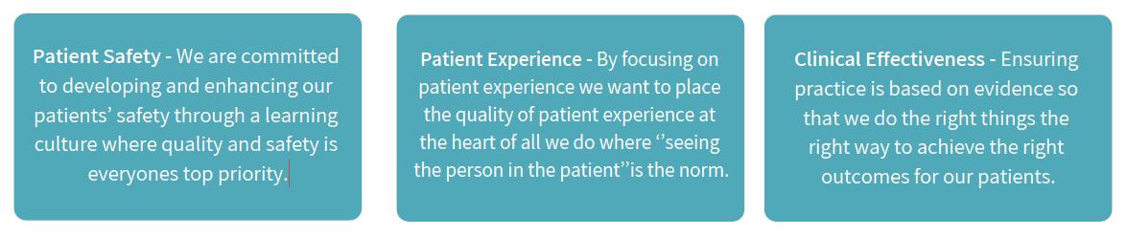

Our Quality Strategy has been developed to ensure patients are safe in our care, to provide patients with the best possible clinical outcomes for their individual circumstances and to deliver an experience of hospital care which is as good as it possibly can be.

With this care model in mind we use the following three priority domains:

* **Patient Safety Domain**
* **Patient Experience Domain**
* **Clinical Effectiveness Domain**

**Defining Quality?**

The NHS Five Year Forward View ([NHS England 2014)](https://www.england.nhs.uk/publication/next-steps-on-the-nhs-five-year-forward-view/) highlights that the definition of quality in health care is enshrined in law and includes three key aspects: patient safety, clinical effectiveness and patient experience. A high-quality health service exhibits all three. However, achieving all three ultimately happens when a caring culture, professional commitment and strong leadership are combined to serve patients.

The *NHS next stage review* ([Department of Health 2008](https://assets.publishing.service.gov.uk/government/uploads/system/uploads/attachment_data/file/228836/7432.pdf)) also defined quality based on the same three criteria which will shape the Trust’s approach to quality and our quality governance framework:

* **Safety:** doing no harm to patients.
* **Effectiveness of care:** including preventing people from dying prematurely, enhancing quality of life and helping people to recover following episodes of ill health.
* **Experience of care:** this should be characterised by compassion, dignity and respect.

The NHS Outcomes Framework ([Department of Health](http://www.NHS) 2017) (Appendix 1) and the Care Quality Commission’s Key Lines of Enquiry (CQC 2018) safe, effective, care and well led are also based around Lord Darzi’s (2008) domains which cannot be viewed each in isolation but as interlinked, with equal importance being placed on each (Doyle, Lennox , Bell 2013). In addition, each of the domains is influenced by leadership (Well‐led) or resources (Sustainable use of resources) as outlined in the diagram.



|  |
| --- |
| Local Quality Indicators |

Our current Quality Improvement Strategy has run as planned until the end of March 2021.

In **year one** of this Strategy 2021/22, there are three priorities and nine new local quality indicators, with new stretched local quality indicators to be identified commencing in **year two** and becoming fully embedded in **year three.**

Year one 2021/22 local quality indicators are listed below and detailed in the ‘Plan on A Page’ below.

|  |  |
| --- | --- |
|  | **Patient Safety Domain**   * Gram Negative Bloodstream Infections – A 5% Reduction in Gram Negative Bloodstream Infections (GNBSI). * Improvement in the communication process for DNACPR * COVID-19 Recovery, waiting list management, appropriate clinical review oversight |
|  | **Clinical Effectiveness Domain**   * Embedding the Medical Examiner role across the Trust and Community Services. * Ensure effective decisions about health care are based on the best available, current, valid reliable evidence. * CBU Governance to be strengthened ensuring consistency across the organisation. |
|  | **Patient Experience Domain**   * Implementation of the End of Life Serious Illness Programme * Development and implementation of the Trust Learning Disability and Mental Health Strategies. * Nutrition- to ensure that patients have access to a choice of food and nutrition. |

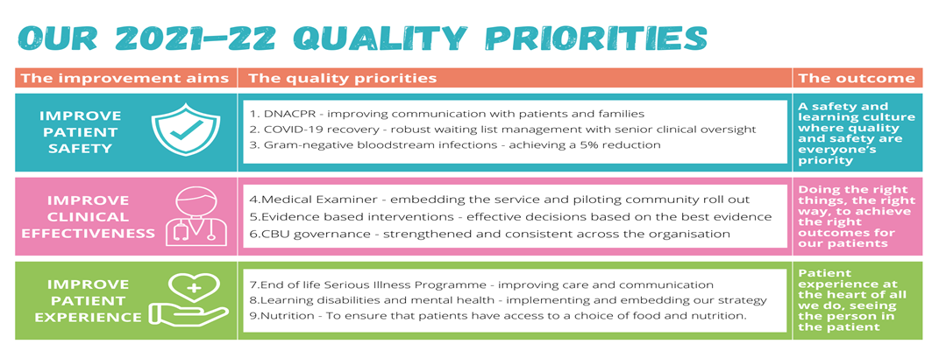

|  |
| --- |
| Quality Governance Framework -Assurance and Scrutiny |

**Quality Governance Framework**

Quality Governance is the combination of structures and processes at and below Trust Board level to ensure and assure the quality of our services, together with systems to monitor and assure the Trust Board of Directors. These are listed below.

* **Board of Directors**

The Board of Directors has overall responsibility for the services that we deliver and is accountable for operational performance as well as the implementation of Strategy and policy. A quality dashboard is reported monthly to the Board of Directors. Where possible we include performance indicators to measure and benchmark our progress against each quality improvement priority and local quality indicators.

* **Quality Assurance Committee**

The Quality Assurance Committee provides assurance to the Trust Board of Directors in respect of clinical quality and patient safety, effectiveness and experience through robust reporting and performance monitoring.

* **Patient Safety and Clinical Effectiveness Sub Committee**

The progress of each priority is reported on a quarterly basis to the Trust’s Patient Safety and Clinical Effectiveness Sub Committee which reports into the Quality Assurance Committee.

* **Clinical Business Units**

There are six Clinical Business Units within the Trust, who report into the Executive Directors and provide assurance on Strategy and risk management performance of the Clinical Business Units. The Clinical Business Units are supported by ‘Clinical Support Services’ as well as ‘Corporate Support Services’.

* **Commissioning for Quality and Innovation (CQUIN) Schemes**

This is a programme of work focusing on delivering key quality outcomes for patients, rather than process outcomes. The delivery of schemes is via teams from across our clinical care groups supported by colleagues in information technology and governance so that improvements in quality in specified areas of care are fully embedded in a sustainable

* **Clinical Audit**

Clinical audit is designed to improve patient outcomes. Its purpose is to engage all healthcare professionals in systematic evaluation of their clinical practice against standards and to support and encourage improvement in the quality of treatment and care.

**Quality Governance and Shared Quality Improvement Learning**

Established governance processes for the assurance of quality and safety across the Trust are in place. Regular Quality Assurance meetings also take place with Warrington and Halton Clinical Commissioning Groups aswell as monthly interface meetings.

Over the next year, we aim to establish a new collaborative assurance arrangement for quality issues which are jointly owned by the CCG and the Trust to ensure that we are exploiting every opportunity to improve quality across care pathways which span primary and secondary care.

* For example, WHH currently monitors *Clostridium difficile* infections within the Trust and is held to account for incidents where preventable infections occur. Some of these infections arise within community settings and are not attributed to the Trust, yet there may be opportunities for the Trust to share learning and expertise in order to prevent these community acquired infections. A joint governance arrangement may allow a population health-based approach to reduce the overall number of infections and reduce the overall impact of this infection.
* For 2021/22, we will focus on Increasing the improvement capability and capacity across the Integrated Care System through the sharing of training and learning opportunities from the Quality Improvement approaches undertaken by the Quality Academy.

In addition, in order to deliver this new Quality Strategy, these objectives will be extended to include assuring Warrington and Halton Partners of Health and Care of quality standards being met forming part of the newly emerging Integrated Care System. This integrated approach to health and care will be delivered through care bundles and care pathways to ensure that people are cared for as close to home as possible by the appropriate professional, and only admitted to hospital when they really need acute care. The Quality Strategy has the potential to greatly improve the health of people living within the Warrington and Halton locality and beyond.

**Care Bundles**

Care Bundles are ‘best practice’ clinical interventions, with an applied research base, that involve key clinical management steps that have been demonstrated to improve patient outcomes. The quality goals for 2021-24 will include achieving national benchmarks for implementation of the care bundles building on the work for stroke, frailty, Acute Kidney Injury (AKI), Venous Thromboembolism (VTE), Sepsis and the SAFER patient flow bundle.

**GIRFT, Right Care and Model Hospital**

The Trust acknowledges the value of utilising best practice evidence and benchmark data to improve outcomes. As such, the Clinical Business Units (CBU’s) are actively engaged in the GIRFT programme and utilising the Right Care and Model Hospital data. During 2019/20, the Trust reviewed the current systems and processes which support the engagement in these programmes with a more robust system being implemented in 2020/21 and embedded in 2021/22 and beyond. This is to ensure a consistent, coordinated and rigorous approach to analytical review and implementation of recommendations with an overall aim to reduce unwarranted variation; to improve care, outcomes and to reduce cost.

**Care Pathways for long-term conditions**

The Trust acknowledges the value of a care pathway as a tool that enables practitioners to provide better health care and better patient outcomes at a lower cost. The Trust will continue to focus on implementing NHS Right Care Pathways which support local health systems to think strategically about designing optimal care for people (and their carers) with long term or high impact conditions. Right Care is a programme committed to reducing unwarranted variation to improve people’s health and outcomes and reduce inequalities in health access, experience and outcomes. It makes sure that the right person has the right care, in the right place, at the right time, making the best use of available resources <https://www.england.nhs.uk/rightcare/what-is-nhs-rightcare/>

The quality goals for 2021-24 will include achieving implementation of the Right Care Pathways and building on the work for:

* **Cardiovascular and Respiratory conditions:** Embed the national priority initiatives for NHS Right Care Pathway for cardiovascular and respiratory conditions.
* **Frailty:** Embed the NHS Right Care Frailty Pathway and Toolkit which supports systems to understand the priorities in frailty identification and care, and key actions to take. It provides opportunity to assess and benchmark current systems to find opportunities for improvement.
* **Epilepsy:** Embed the NHS Right Care Pathway and toolkit for epilepsy, focusing on the key components for epilepsy care across the system and reducing unnecessary emergency care for people living with epilepsy.

|  |
| --- |
| Maternity Quality Indicators |

This Quality Strategy is an important link to the WHH Maternity Services Strategy as it sets out additional measures to drive improvement further and faster.

We aim to put the family at the centre of decisions so that all women, babies and their families get the highest quality of care which meets their needs, and improves their overall physical, mental and emotional wellbeing.

To support this we will:

* Collect and share data on the quality and delivery of our maternity services as outlined in the Maternity Performance Indicators dataset.
* Support local teams in reviewing data and undertaking service improvement.
* Review the Ockenden report and implement the 7 immediate and 26 local safety actions; and benchmark ourselves against the actions until full compliance is achieved.
* Monitor ongoing compliance with the implementation of the NHS Litigation Authority (NHSLA) 10 safety standards for maternity services ready for submission on 15 July 2021.
* Analyse the summary of themes arising from the Healthcare Safety Investigation Branch (HSIB) maternity programme and implement the safety recommendations and learning to improve systems and processes in order to reduce risk and improve safety
* Undertake a gap analysis on all MBRRACE reports to inform maternity care from the UK.
* Review the report of the National Maternity Review Better Births: Improving outcomes of maternity services in England and implement the recommendations to improve outcomes of the maternity services.
* Undertake a gap analysis using the perinatal safety surveillance tool and taking timely and proportionate action to address any concerns identified.
* Utilise the maternity self-assessment tool to help maternity services achieve sustained improvement across the five CQC domains – i.e. are services safe, effective, caring, responsive to people’s needs, and well-led.
* Develop Maternity Voices Partnerships (MVPs) to provide a mechanism for ongoing feedback and co-design of services and, at their best, enable co-production on maternity.
* Work in collaboration with other partners to promote overall population health including alongside Local Authorities and Public Health. This includes early years, 0-19 years, and speech and languages services to ensure the greatest start for families.

|  |
| --- |
| National Quality and Safety Indicators |

As well as recognising well‐led services, the Accountability Oversight Framework [(Department of Health 2017)](http://www.NHS) enables early identification and support if performance falls below the expected level. Safety measures are weighted and override all other measures, ensuring that safety is central to every Hospital, including WHH’s Strategy and that leadership teams are held to account for the quality and safety of their services.

The detail of the metrics included in the Safety and Patient Experience domains of the Accountability Oversight Framework are provided below for information. The metrics within the Accountability and Oversight Framework demonstrates the important link with the local quality indicators within this Quality Strategy.

|  |  |
| --- | --- |
| **Accountability Oversight Framework Domain Key Performance Indicators** | |
| **Patient Safety** | **Patient Experience** |
| Hospital Standardised Mortality Ratio (HSMR) | Friends and Family Test (FFT) % Extremely Likely |
| Summary Hospital‐level Mortality Indicator (SHMI) | Complaint Volumes (trends) |
| Mortality outlier alert | Complaints not responded to by day 35 |
| Never Events | PALS Concerns Volumes (trends) |
| Attributable/avoidable Infection Prevention &Control (IPC) indicators (MRSA, CPE, VRE, Clostridium Difficile) | Ward/department accreditation progress and outcomes (continuous improvement profile) |
| Trainees satisfaction score (Annual Rating Only) | Food and Nutrition Patient Experience Survey |
| Falls with harm (3‐5) by patient bed day | Pain Management Patient Experience survey |
| Fairness and effectiveness s of reporting score (Annual Rating Only) | **Workforce and Leadership** |
| Pressure ulcers (Grade 3+ avoidable | Attendance |
| Confirmed level 5 harms | Turnover (Rolling 12m) |
| VTE Risk Assessment | Engagement Score (quarterly) |
| Delayed Transfers of Care | Appraisal ‐ Medical |
| **Clinical Operational Excellence** | Appraisal ‐ Non‐Medical |
| Diagnostic Performance Confirmed level 5 harms A&E | Appraisal Quality (quarterly) |
| 4 Hours Arrival to Departure | Trust Mandatory Training ‐ Clinical |
| RTT ‐ 18 Weeks (Incomplete Pathways) | Trust Mandatory Training ‐ Corporate |
| Cancer Urgent 2 Week Wait Referral | Nurse Retention |
| Cancer 2 Week Wait breast Symptom | BME Staff Retention |
| Cancer 31 Days First Treatment | Band 5 Nursing & Midwifery Turnover (Rolling 12m) |
| Cancer 31 Days Sub Surgical Treatment | % Band 5 Nursing & Midwifery Vacancies vs Est  (Rolling 12m) |
| Cancer 31 Days Sub Chemo Treatment |
| Cancer 62 Days RTT | Medical Agency Spend (£k) |
| Cancer 62 Days Screening | Proportion of appointments that are internal |
| Cancelled operations ‐ rescheduled <= 28 days | Median time to complete ER Investigations |
| 12 hour trolley waits | **Strategy** |
| **Finance** | Existence of a Strategy |
| Delivery of Financial Plan | Existence of annual plan |
| Delivery against plan |

|  |
| --- |
| Research and Innovation |

At both Warrington and Halton Hospital sites we participate in studies to promote medical research and improve care in the future for certain conditions. These studies are large studies that often involve many patients in many different hospitals.

Our Research and Development (R&D) Department works closely with the clinical Business Units within the hospitals to ensure we can offer patients the opportunity to participate in high quality research that has been approved by an independent ethical body.

The Trust recognises that participation in clinical research demonstrates our commitment to improving the quality of care we offer both by helping ensure our clinical staff stay abreast of the latest possible treatment options and because active participation in research leads to successful patient outcomes.

The Research and Development department is funded by the National Institute for Health Research and takes part in nationally funded studies, and real life patient stories on these can be found [here.](https://www.nihr.ac.uk/patients-carers-and-the-public/i-want-to-learn-about-research/real-life-stories.htm) In addition, WHH have recently opened the Halton Clinical Research Unit (HCRU) and are developing a partnership board with Liverpool University Hospitals NHS Foundation Trust (LUHFT). Our own dedicated research and clinical trials facility at our Halton Hospital site supports our research ambitions and aims to widen participation in research across Warrington, Halton and surrounding areas.

To support this, we will:

* Support our staff to develop skills in research and innovation.
* Routinely offer patients in all specialities the opportunity to participate in high quality research studies.
* Build research activity into our measures of performance and clinical quality.
* Strengthen research governance and expand the research and development support function.
* Increase the research activity of the Trust and the research income from national funding bodies.
* Develop strategic partnerships with neighbouring organisations to increase our research potential.
* Actively translate research into practice to improve clinical and quality outcomes
* Work closely with our commercial development team to identify opportunities to generate income, reinvest and drive quality of care through best evidence and innovation.

In order to support research, over the next three years we will:

* Maintain or improve the number of research trials available for patients to participate in and
* Improve the number of patients participating in clinical research trials.
* Maintain and improve performance in initiating clinical trials and studies.
* We will collect regular feedback from patients who have experienced care as part of a research study through:
  + patient satisfaction surveys,
  + friends and family initiatives and
  + regular public engagement events.

The Health Education England (HEE) Research & Innovation (R&I) Strategy identifies the importance of a workforce that embraces R&I as being central to improving the quality of care and patient experience. Historically, practice-based research has more commonly been developed by medical practitioners, with non-medical professionals predominantly supporting research delivery. We aim to redress this balance and over the next three years we aim to promote Nursing, Midwifery and Allied Health Professional (NMAHP) Research and a three year vision with the overarching aims of:

* Increasing research awareness amongst NMAHPs
* Increasing the use of research in practice by NMAHPs
* Increase the number of NMAHPs participating in research, and
* Increase the volume of research studies undertaken and led by NMAHPs.

The link between research active organisations and those that deliver the highest quality care is clear and so our commitment to research will be essential if we are to continually improve the quality of the services we deliver.

|  |
| --- |
| Identifying Quality Improvement Priorities |

How we identify our improvement priorities – stakeholder engagement.

The Trust has a duty to fully engage with stakeholders and members to ensure that we are listening to their views on quality and Quality Priorities moving forward.

The Trust Quality Priorities have and will continue to be identified through receiving feedback and regular engagement with governors, staff, patients, the public, and commissioners of NHS services, overseeing scrutiny groups and other stakeholders. This will ensure that the quality of care delivered meets the needs of the population that we serve. Progress on the planned improvements will be reported through the Trust’s Quality Assurance Committee and ultimately through to the Board of Director’s.

Our staff, governors, members and patients are the eyes and ears of the organisation and their views are constantly sought to ensure that we are focussing on the things that will make the most difference. We surveyed staff, patients and visitors, through the Staff Survey and the Friends and Family Test and from those results we capture the views of the staff and wider public in relation to the range of priorities.

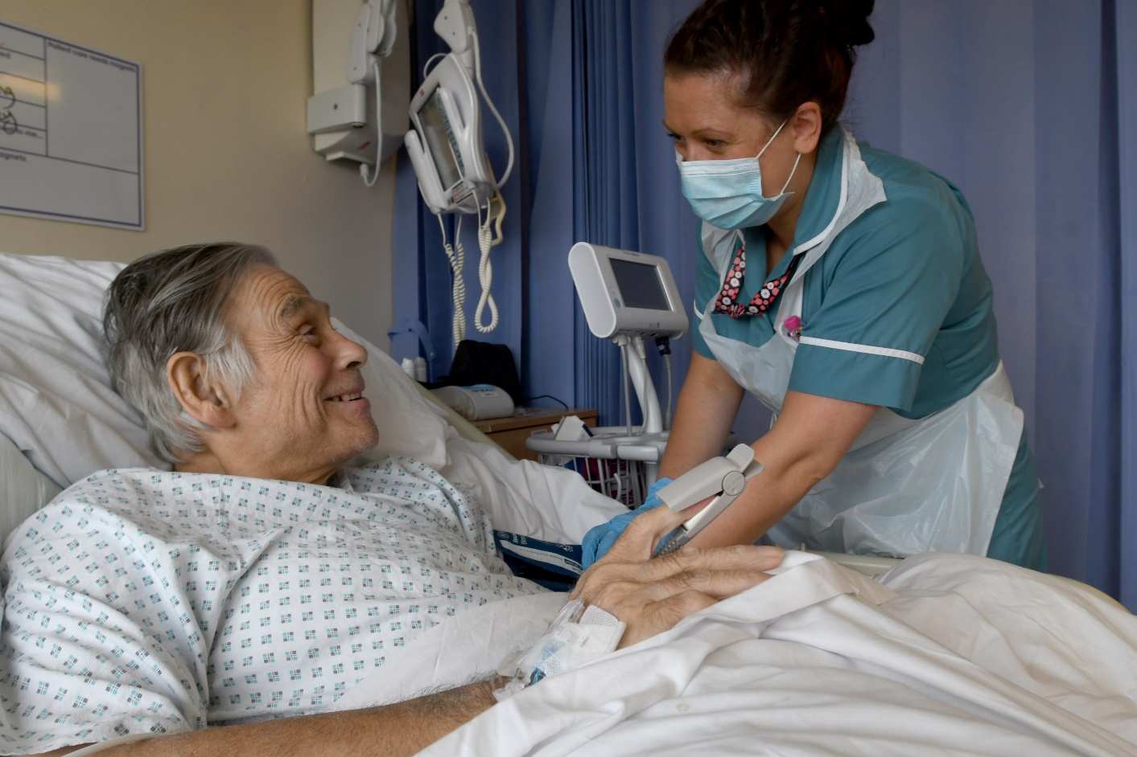

|  |
| --- |
| Quality Improvement Across the Integrated Care System (ICS) |

**Quality Improvement in Our Healthcare System**

Our partnerships make us stronger; by investing in them, we will deliver the best possible care to our communities.

Working in partnership across the Integrated Care System has been a fundamental part of our improvement journey so far and we will continue to underpin all our work as we continue that journey.

Our drive to improve the quality of care delivered across our communities will see the Trust work increasingly though partnerships across our localities. We will develop our role as part of an integrated offer, working more closely with our Commissioners and with other local providers, including GPs, Community and Mental Health Trusts, and colleagues in Social Care. This drive to improve care through collaboration is reflected through the recent Integration and Innovation White Paper, which outlines the requirements for system working. We will work as part of a joined-up system across Cheshire and Merseyside, contributing to and learning from best practice across the region, and working to ensure equity of care for our communities.

We are already involved in several projects which achieve these aims and have more planned to deliver over the next 3 years. These include:

* Our New Hospitals Programme
* The creation of a Clinical Services Hub in Runcorn Shopping City
* Development of the Warrington Town Deal Health and Wellbeing Hub, and the Runcorn Town Deal and Education Hub
* Partnership with University of Chester
* Enhanced partnership working with St Rocco’s Hospice
* Prevention Pledge and Social Value Award
* Supporting elective recovery
* Developing workforce models to support best patient care across our localities
* Developing a continuity of carer model across our midwifery services

In addition to measuring the quality improvement activity within our hospital, we are now looking to measure activity within the community and increasingly across care pathways which span the primary and secondary care divide. Quality issues that were formerly the province of one part of the healthcare system are now shared by the whole Integrated Care System. We are starting to look jointly with our partners at the opportunities for quality improvement.

To support this we will:

* Develop streamlined clinical pathways and delivery of seamless care with partner organisations.
* Ensure that service and care pathway design is informed by patients, families and carers.
* Develop a Communication and Engagement Strategy that has building partnerships at its core.
* Demonstrate the behaviours needed as an organisation to foster strong relationships – open, honest, committed to putting our patients, colleagues and communities first.
* Create opportunities to more effectively collect, evaluate and act on the opinions and ideas that are fed back through our partners.
* Engage with and empower our colleagues, encouraging them to innovate and use best practice by removing the barriers to progress. We will make it easier to turn good ideas into practice.
* Cement our partnerships and joint working arrangements through the use of patient enabled IT across health organisations and people’s homes.
* Recognising that the local, neighbourhood needs of citizens will vary across Warrington and Halton and beyond; our partnerships must add personal value to the citizens and colleagues alike.
* To deliver outstanding care, both now and in the future. We will encourage academic and commercial partners to work with us and be innovative, bringing the very best health outcomes for our citizens.

|  |
| --- |
| Quality Improvement Priorities |

The Board of Directors, in partnership with staff and Governors, has reviewed data relating to quality of care and agreed our quality improvement priorities for 2021/22 as outlined below:

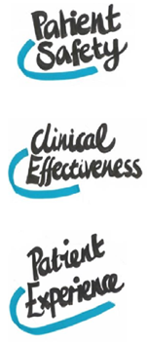

**Priority 1:** We will reduce avoidable harm and deterioration and focus on COVID-19 recovery by managing and reducing clinical and operational risks.

**Priority 2:** We will improve outcomes, based on evidence and deliver care in the right place, first time, and every time.

**Priority 3:** We will focus on the patient and their experience, adopting ‘no decision about me without me’ as a way of life and we will get the basics right so our patients will be warm, clean, and well cared for.

In order to embed the above three quality improvement priorities, we have established nine local quality indictors to support their implementation. The priorities have been chosen based upon national and local drivers and our internal governance intelligence, identifying areas for improvement. Emphasis remains upon working across organisational boundaries in partnership with others, to ensure that we provide the efficient and safe patient pathways to optimise health outcomes and experience for our patients.

Full details of the Patient Safety, Clinical Effectiveness and Patient Experience nine local quality indictors can be seen in the next section below.

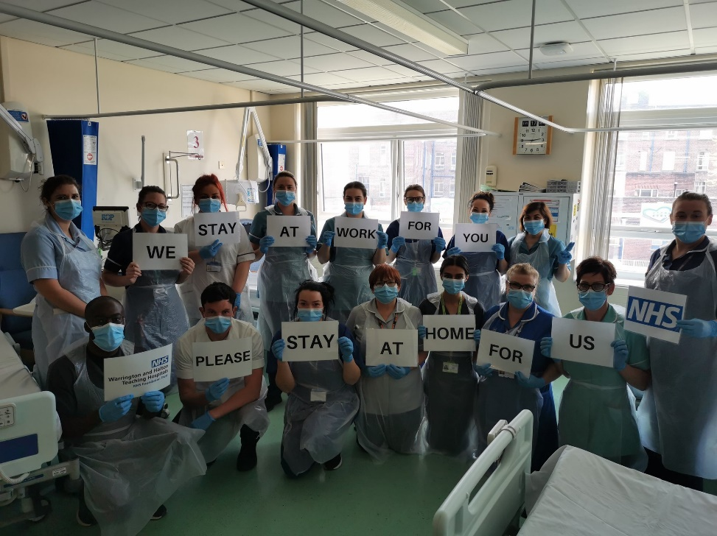

|  |
| --- |
| The Way Forward - Our Approach to Quality Improvement |

Achieving this vision will require us to build upon our experience using the Quality Improvement approach which has created an enthusiasm and a focal point for colleagues wanting to improve the services that they deliver. We need to go beyond this and equip our staff with the skills and capacity to systematically improve the quality of care.

To ensure continuous improvement across all aspects of our work, we will continue to support staff to lead improvements by providing education and training in skills and practices within quality, safety and effectiveness.

We will continue to work with the Innovation Agency and external partners to embed a culture of innovation within the Trust. Through working with the Innovation Agency, we will improve health and care and generate economic growth. This is a key aspect of both the Quality and Quality Academy Strategies.

We will connect with regional networks of the NHS and academic organisations, local authorities, the third sector and industry by responding to the diverse needs of our patients and populations through partnership and collaboration.

We will continue to provide Foundation Quality Improvement (QI) Practitioner level training sessions which provide staff with the foundation of quality improvement. The Kaiser Permanente dosing formula describes the numbers of staff that should have a certain level of quality improvement skills to build capability and capacity for improvement within an organisation. The Trust are working toward achieving 100% compliance and are on trajectory to achieve this by March 2021 in accordance with Kaiser Permanente recommendations.

The Quality Academy has created a bespoke improvement training programme for the Trainee Workforce (Foundation Year 1 to Specialist Trainee 8) which will continue to be delivered by the Quality Improvement Specialist and the Clinical Audit Manager for Foundation Year doctors. They will also be provided with a pick list of audits and improvement projects that relate to Trust priority audits and quality improvement work, enabling them to contribute to the Trust quality improvement work.

Improving quality requires leadership and expertise at all levels of service delivery. The step change in quality improvement in the next three years will come from a generation of quality improvement specialists, equipped with the knowledge and skills of improvement methodology which can be applied across the whole organisation and right down to the microenvironment of individual patient care. Our focus will be on training of this increasingly numerous groups of individuals and investing in them to provide the impetus for large scale quality improvement. Progress will be monitored, measured and reported quarterly through the Quality Academy Board, and a quarterly Quality Report to the Quality Assurance Committee will track milestones for the Quality Account priorities.

|  |
| --- |
| Measuring, Monitoring and Publishing Quality Improvements & Performance |

The Trust maintains its commitment to delivering high quality services by monitoring effectiveness and studying outcomes. The Quality Assurance Committee will oversee the implementation of this Strategy, holding Clinical Business Units (CBU) Clinical Directors and Senior Leadership Teams to account for local delivery of the Strategy.

We will continue to be open and transparent, publishing progress against our Quality Priorities at our Quality Assurance Committee and public Board meetings. We will do this by producing a monthly Integrated Performance Dashboard and Quality Dashboard Report outlining the Trust’s performance against each of the quality domains.

Moving forwards, we want to continue to improve the way we present and share data by using sophisticated data analysis methods including statistical control charts. By continuing to improve the way we display data it will make it easier for staff, from the ward to the Board, to understand where we are making improvements and where we need to increase our efforts. Continual measurement will also help us ensure that any improvements we do see are sustainable in the long term.

The Care Quality Commission’s (CQC) Insight reports will also play an important role in the way we measure the quality of our care. The Trust is now on a journey to achieve a CQC rating of ‘Outstanding’ and this document will assist us in monitoring our performance and detecting any deterioration that needs to be addressed. The CQC ‘Insight’ report is a data dashboard and is produced on a monthly basis. It provides an overview of the various indicators for risk and quality as monitored by the CQC and gives some indication of the level at which the CQC currently rates each provider. Each month an Integrated Performance Report Dashboard will be presented to the Board containing the salient sections of the CQC ‘Insight’ report focusing on any areas of change since the last update was received.

We look forward to assuring the Board of Directors and the Integrated Care Partnership over the coming years about how this new Strategy is being implemented and reporting the quality improvements that it will bring to the health and care of people who live across Warrington and Halton and beyond. Our aim is to ensure that all staff who work in our hospitals strives for excellence in all that they do and believe that the focus of the organisation is on providing safe care, which is responsive, caring and effective in terms of providing good outcomes for our patients. We will also continue to produce an annual Quality Account which will be our way of demonstrating to the public the progress we have made against our Quality Priorities each year and what we plan to improve in the succeeding year. This document will also demonstrate our delivery of CQUIN Schemes and our commitment to participating in all relevant national audits, and the outcomes of which provide another vital means of measuring the quality of our services.

|  |
| --- |
| Setting a Clear Direction and Priorities |

|  |  |  |
| --- | --- | --- |
| Quality and Safety are routinely placed on the top of the Trust’s agenda. Each Trust Board meeting starts with a patient story with a focus on quality and safety ensuring that the message is clear to all – this is our priority and we will ensure there is always time to discuss quality and safety issues.  This commitment to quality and safety has also been demonstrated by the Clinical Business Unit Clinical Directors who advocate, advise and steer the direction of the quality and safety agenda within the organisation. The Clinical Directors are highly motivated and clinically credible individuals who, by working closely alongside the Trust’s senior nursing leadership, act as ‘champions’ for the quality and safety agenda, offering strategic leadership on key priority areas and helping to develop a culture for continuous improvement by role modelling within the organisation.  Successfully managing quality relies on commitment, consultation and co-operation with all staff from the ward to the Board. Each year discussions with the Board of Directors, the Council of Governors, patient representatives, staff and public will take place in order to ensure Quality Priorities are identified to focus efforts for the coming 12 months. We will ensure the Quality Priorities are appropriate, meaningful and resonate with all. Data and evidence will also play a vital role; each year we will ask where there is scope for improvement and in which areas is the quality gap the greatest? |  | The feedback from our front-line staff, Governors and patients will help set core Quality Priorities that have an overarching impact across the organisation. Whilst these will change year on year, it is likely that the following will always focus in some guise:  **Patient Safety Domain:**   * Reducing avoidable harm and deterioration   + Reducing healthcare acquired infections   + Reducing medication errors   + Reducing Serious Harm Falls   + Reducing Hospital Acquired Pressure Ulcers   + Safe staffing levels. * COVID-19 Recovery, waiting list management * Focus on having no avoidable deaths by reducing clinical and operational risks * Increasing incident reporting and learning from error; Implement the NHSE Patient Safety Response Framework (PSIRF) which will replace the current Serious Incident Framework when launched.   **Clinical Effectiveness Domain:**   * Ensuring mortality rates are at least within expected limits * Participating in national and local audits * Effective safe discharge. * Improve outcomes, based on evidence: such as National Institute of Clinical Excellence (NICE) and * Deliver care in the right place, first time, and every time. Getting It Right First Time (GIRFT)   **Patient Experience Domain:**   * Focus and acting on what patients tell us and co-creating solutions to challenges they face * Involving patients in their care and embracing the ‘no decision about me without me’ philosophy. * Ensuring nutrition and hydration for patients:   + MUST risk assessments are completed daily.   + Weekly re-screening of MUST and appropriate dietetic referral if MUST ≥2 * Get the basics right so our patients will be warm, clean, and well cared for. |

|  |
| --- |
| Equality, Diversity and Inclusion Quality Indicators |

**Providing High Quality, Accessible and Responsive Services, With Focus Upon Population Health and Health Inequalities**

As a Trust, we remain committed to promoting equality and diversity amongst our workforce, ensuring our services and employment practices are fair, accessible, and inclusive for the diverse communities we serve and the workforce we employ. This is reflected and reinforced in our ‘vision and values’, celebrating diversity and creating an inclusive culture for our patients and workforce.

We take steps to ensure that we are a great employer which values and welcomes the different ideas, skills, behaviours and experiences of our colleagues. We also aim to foster a culture that promotes wellbeing and mental health and provides support to enable all our colleagues to thrive.

For our patients, we pledge for ‘Better Health Outcomes for All’ and to ‘Improve Patient Access and Experience’.

To support the achievement of this and ‘Improving Our Quality’ for patients we will:

* Ensure we provide a positive patient experience for all patients regardless of their identity and protected characteristics.
* Ensure accessible information and communication with patients.
* Ensure the recording of equality data so that reasonable adjustments are identified and provided.
* Aim to reduce health inequalities by advancing equality of opportunity for all patients.

In order to demonstrate that we are achieving this and ‘Improving Our Quality’ for staff we will:

* Ensure that WHH is a fair and inclusive employer of choice.
* Ensure equitable career progression for all staff groups and for staff of all protected characteristics.
* Foster talent which is fair and inclusive.
* Monitor staff experiences and respond appropriately.
* Ensure fair recruitment processes.
* Develop case studies to improve awareness and understanding of different protected characteristics amongst staff and patients.
* Ensure equality and diversity is championed and embedded at a local level across the trust.
* Seek assurance that services are delivered in a way that is consistent with the Public Sector Equality Duty

In addition, WHH will ensure that we will:

* Continue working towards meeting the requirements of the anticipatory duty to make reasonable adjustments on public functions in the Equality Act.
* Enhance the equality, diversity and inclusion workstream to focus on all protected characteristics for patients and workforce through engagement with community partners.

|  |
| --- |
| Conclusion |

We are confident that by implementing this Strategy and continuing to **always put our patients first** and put patients at the heart of everything we do; we will continue to ensure that our services are safe, effective, caring, responsive and well-led.

By working hard to foster a culture of continuous improvement, by empowering staff and patients to make the changes they want to see, we will continue to deliver the best possible care to the people of Warrington and Halton and beyond.

We will monitor the implementation of this Strategy closely and look forward to working together to make the Warrington and Halton NHS Teaching Hospitals NHS Foundation Trust even better.

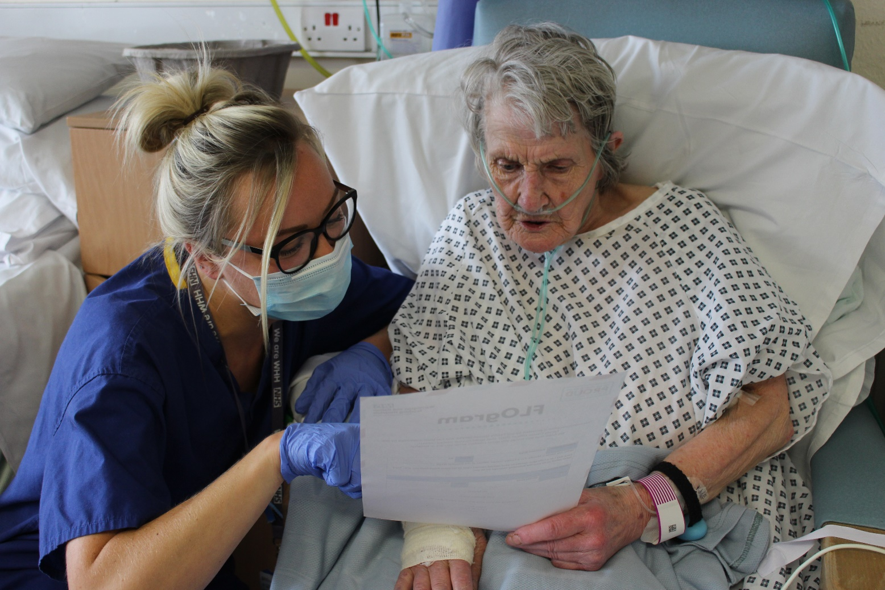

References

Care Quality Commission (2017). Key lines of enquiry prompts and ratings characteristics for healthcare services. Available at: [https://www.cqc.org.uk/](http://www.cqc.org.uk/sites/default/files/20170609_Healthcare)s[ites/def](http://www.cqc.org.uk/sites/default/files/20170609_Healthcare)au[lt/files/20170609_Healthcare](http://www.cqc.org.uk/sites/default/files/20170609_Healthcare)‐services‐KLOEs‐prompts‐and‐characteristics‐FINAL.pdf

Department of Health (2017). NHS Outcomes Framework. Available at: <http://www.NHS> Outcomes Framework.uk

Department of Health (2008). High quality care for all: NHS Next Stage Review final report. Department of Health; London.

Doyle C, Lennox L, Bell D (2013). A systematic review of evidence on the links between patient experience and clinical safety and effectiveness. BMJ Open.

NHS England (2019). Patient Safety Strategy. Available at: [https://www.england. patient-safety-Strategy/](https://www.england.nhs.uk/patient-safety/the-nhs-patient-safety-strategy/)

NHS England (January 2019). NHS Operational Planning and Contracting 2019/20 which can be accessed via the following link: <https://www.england.nhs.uk/rightcare/what-is-nhs-rightcare/>

|  |
| --- |
| Additional Information |

For more information about our Quality Strategy and programmes please contact:

Clinical governance and Quality Department Tel: 01925 662789

**Warrington and Halton NHS Teaching Hospital NHS Trust**

Lovely Lane, Warrington WA5 1QG

[www.whh.nhs.uk](http://www.whh.nhs.uk)

|  |
| --- |
| If you would like to receive this document in another format, please do not hesitate to contact us. |





